TITLE OF THE PAPER

Name Surname
Affiliation. E-mail

Name Surname
Affiliation. E-mail

ABSTRACT: abstract abstract abstract abstract abstract abstract abstract abstract abstract abstract abstract abstract abstract abstract abstract abstract abstract abstract abstract abstract abstract abstract abstract abstract abstract abstract abstract abstract abstract abstract abstract abstract abstract abstract abstract abstract abstract abstract abstract abstract abstract abstract abstract abstract abstract abstract abstract abstract abstract abstract abstract abstract abstract abstract abstract abstract abstract abstract abstract abstract abstract abstract abstract abstract abstract abstract abstract abstract abstract abstract abstract abstract abstract abstract abstract abstract abstract abstract abstract abstract abstract abstract abstract abstract abstract abstract abstract abstract abstract abstract abstract abstract abstract abstract abstract abstract abstract abstract abstract abstract abstract abstract abstract abstract abstract abstract abstract abstract abstract abstract abstract abstract abstract abstract abstract abstract abstract.

Keywords: word1, word2, word3, word4, word5.

1. INTRODUCTION

Text text text text text text text text text text text text text text text text text text text text text text text text text text text text text text text text text text text text text text text text text text text text text text text text text text text text text text text text text text text text text text text text text text text text text text text text text text text text text text text text text text text text text text text text text text text.

text text text text text text text text text text text text text text text text text text text text text text text text text text text text text text text text text text text text text text text text text text.

2. SECTION

Text text text text text text text text text text text text text text text text text text text text text text text text text text text text text text text text text text text text text text text text text text text text text text text text text text text text text text text text text text text text text text text text text text

2.1. Section

Text text text text text text text text text text text text text text text text text text text text text text text text text text text text text text text text text text text text text text text text text text text text text text

Text text text text text text text text text text text text text text text text text text text text text text text text text text text text text text text text text text text text text text text text text text text text text text text

Tabla 1. Ejemplo de cabecera de tabla
Column1 | Column2 | Column3 | Column4
text | text | text | text
text | text | text | text
text | text | text | text
text | text | text | text
text | text | text | text
text | text | text | text

Text text text text text text text text text text text text text text text text text text text text text text text text text text text text text text text text text text text text text text text text text text text text text text text

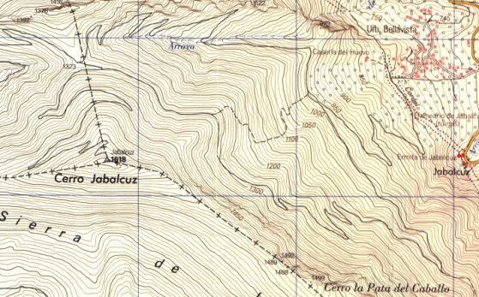
Figure 1. Example of figure title

2.1.1. Section

Text text text text text text text text text text text text text text text text text text text text text text text text text text text text text text text text text text text text text text text text text text text text text text

